30/01/24 **Lecture 2: Page rank algorithm**

MapReduce - Page rank algorithm

* Rank by importance
* Number & Quality of links to page
* PageRank = PDF showing likelihood of visiting any page by clicking on random link

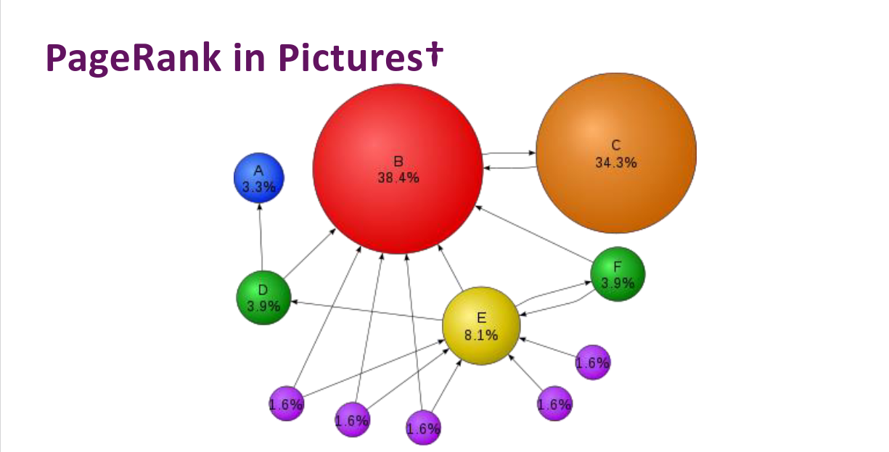

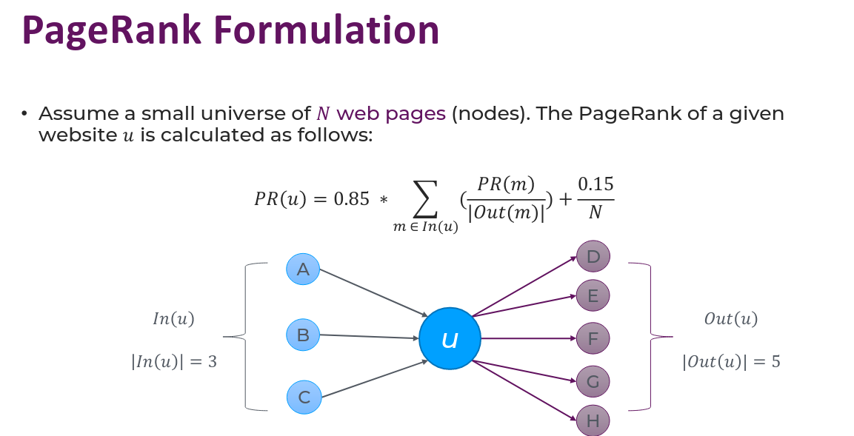

Example

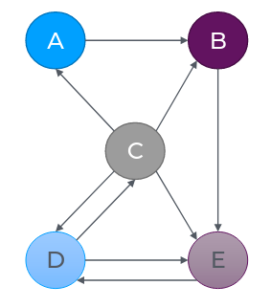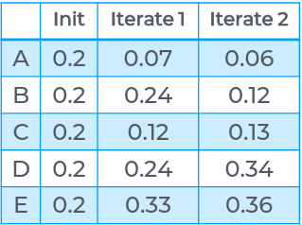

Iterate until probability converges

**Map**

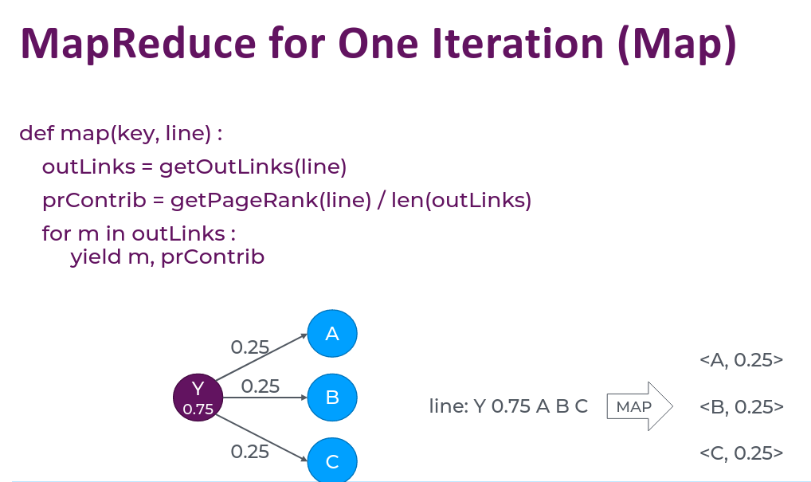

**Reduce**

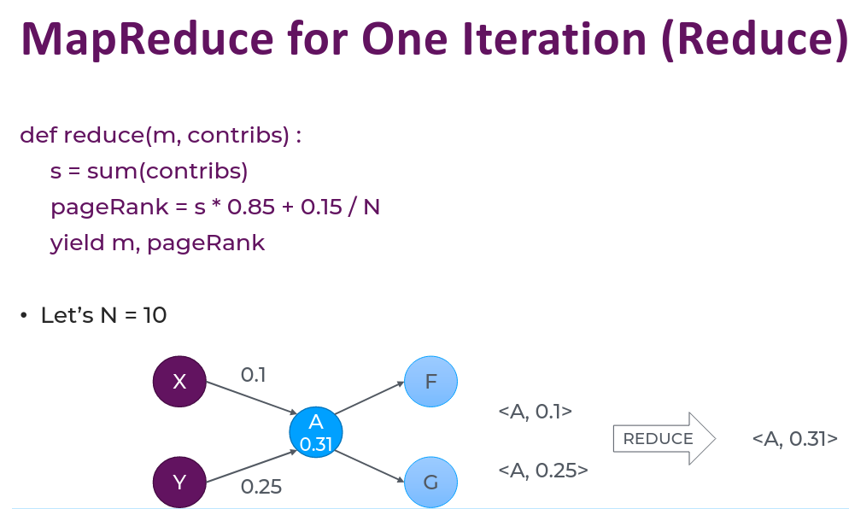

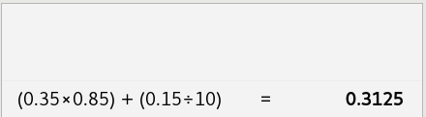

*Algorithm is non-iterative

To make it iterative:

